Alphacrucis University College Field Study to Israel and Jordan

25 November – 10 Dec 2023

Day 1 – Saturday 25 November
Arrive at Queen Alia Airport, Amman. Our first stop for the day will be Jerash, also known as the “city of a thousand columns.” From here, we head to Sheikh Hussein to cross the border into Israel. We will arrive at Ein Gev kibbutz, our hotel on the shores of the Sea of Galilee, which will be our home for the next four nights.
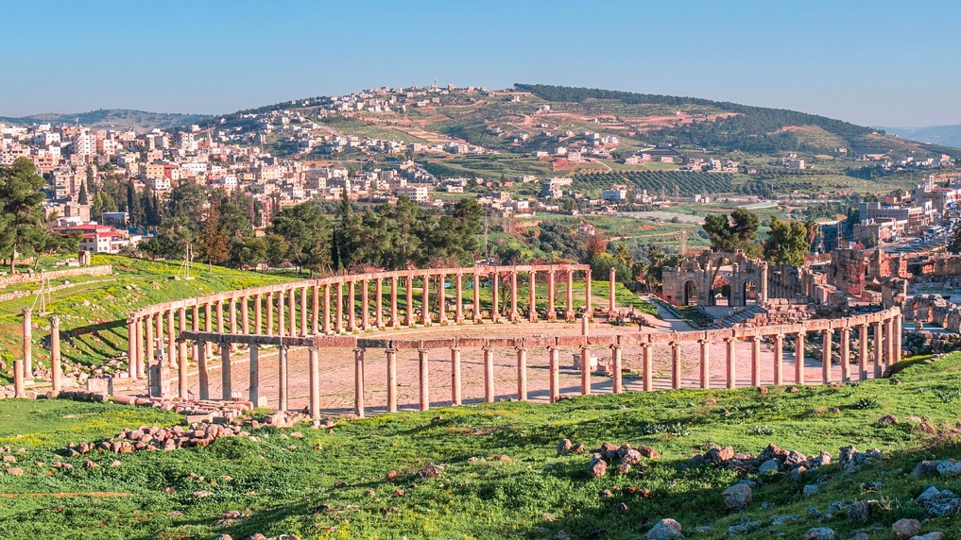

Day 2 – Sunday 26 November
Starting bright and early, we will make our way across to the Mediterranean Coast to Caesarea Maritima, where Paul was held under house arrest for two years. Then we will visit the Bahai Temple Gardens in Haifa, before back to the Sea of Galilee to explore remains of a Jewish hideout on Mount Arbel.

Day 3 – Monday 27 November
Heading up north, now, we visit the ancient city of Dan to see the water source of the Jordan River and a Bronze Age gate dating to the time of Abraham. Then we go to Caesarea Philippi (Banias), to the vicinity where Simon Peter declared to Jesus, “You are the Christ, the Son of the Living God” (Matt. 16:16). With a visit to a Crusader castle and one of the oldest synagogues in the world, it’s sure to be an exciting day.
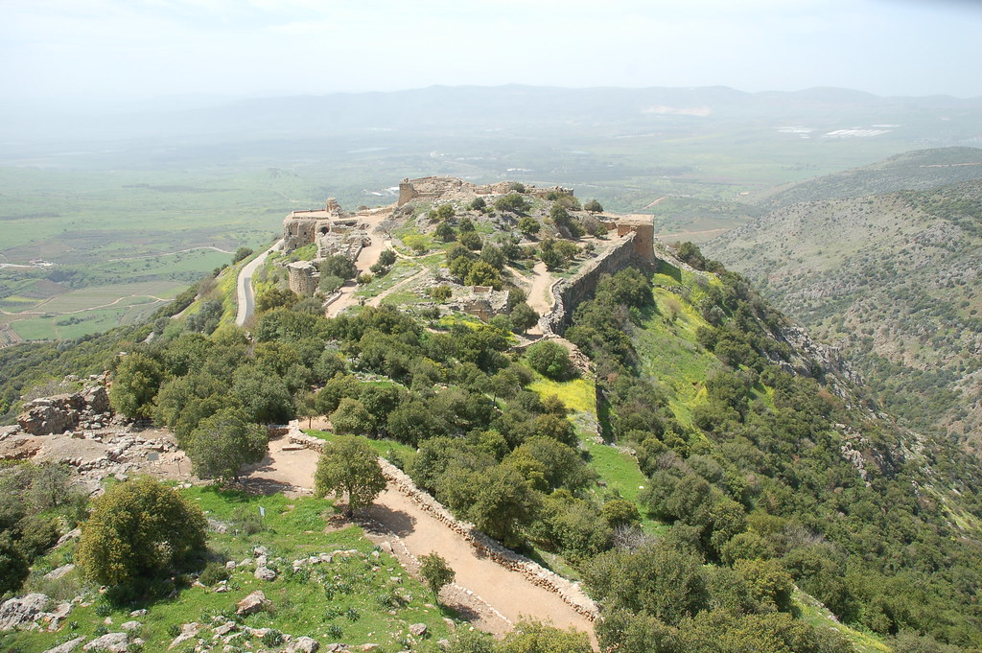

Day 4 – Tuesday 28 November
We start the day with a boat ride on the Sea of Galilee and visit Capernaum and the church of the Primacy of Peter. Then we’ll head to Nazareth Village where we will explore the open-air museum that reconstructs and re-enacts village life in Galilee from the time of Jesus and eat a first-century style lunch.

Day 5 – Wednesday 29 November
Today we, like Jesus, will “resolutely set out for Jerusalem” (Luke 9:51). But first we will stop at Beth Shean (Scythopolis), which was once the centre of Egyptian rule in the northern part of Canaan and was rebuilt by Pompey as a “Rome away from home” in 63 BCE. Did you ever imagine you could walk through a Middle Bronze Age temple on the same day as you sat on an ancient Roman public toilet?! Then we will drive through Jericho to stop in the wilderness of Judea before at last walking down the Mount of Olives, as Jesus once did (Mark 11), perhaps without a donkey.
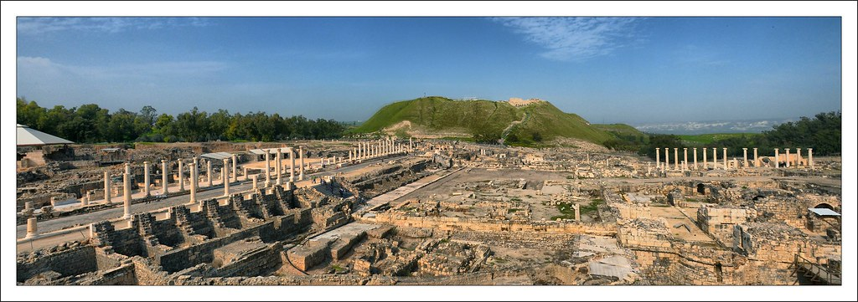

Day 6 – Thursday 30 November
We’ll spend the day in the vicinity of Bethlehem, first exploring the Herodium, one of Herod the Great’s desert palaces, which he built on top of a volcano-shaped hill that he made the highest in the region by literally moving a mountain…(sound like Matt. 17:20 to anyone?) Then we’ll spend the rest of the day exploring the churches and region of Bethlehem.

Day 7 – Friday 1 December
Today is our first full Jerusalem day. We’ll start by walking through knee-high water in a tunnel constructed by King Hezekiah (2 Kgs. 20:20). Then we head to the Temple Mount to walk up the stairs Jesus would have used to enter the Temple. We will then visit the Broad Wall (2 Chr. 32:5) and finish the day at the Upper Room and Tomb of David.
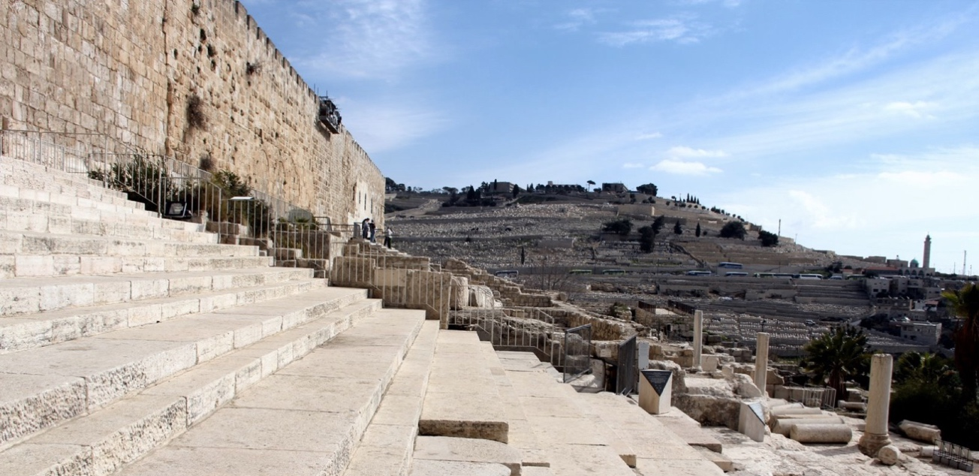

Day 8 – Saturday 2 December
We will start today by visiting one of the holiest, most beloved places in Christian history, the Holy Sepulchre. This is the traditional site of the tomb where Jesus was buried and Christians of all denominations have pilgrimaged to this holy site. Then we visit the Church of St Anne’s and the Pools of Bethesda, where a lame man waited to receive healing from water and instead met Living Water. Finally, we will go to the site often preferred by Protestants for reflecting on the death and resurrection of Jesus, the Garden Tomb.

Day 9 – Sunday 3 December
This is a free day and you are encouraged to visit one of the churches around Jesus, such as a service at Christ Church (Anglican) at 9.30 am, Church of the Redeemer (Lutheran) at 9 am, or King of Kings (Messianic/Pentecostal-esque) at 5 pm.

Day 10 – Monday 4 December
We depart Jerusalem today, but the trip is not over yet! We’ll start the day with a hike through terraced vineyards in the Judean hill country, reflecting on the Poem of the Vineyard (Isaiah 5). Then we’ll explore Elah Valley, the site where David fought his famous battle against Goliath, before heading south to Beersheba where we will visit the ANZAC Memorial of the light horsemen and the ancient site that offers a great example of an Iron Age walled city.
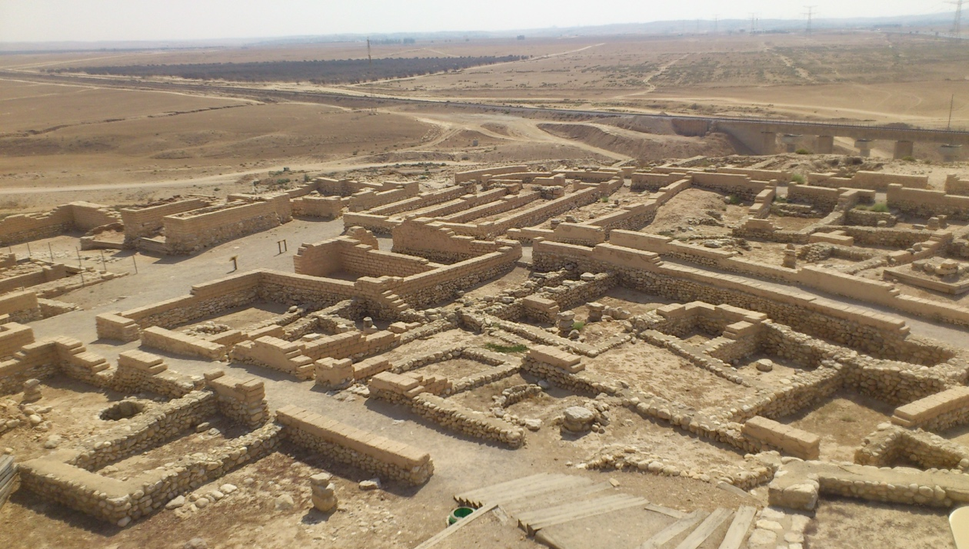

Day 11 – Tuesday 5 December
Now, a day we’ve all been waiting for! Today we will explore the impressive desert fortress of Masada, the place where the Dead Sea Scrolls were found, an oasis in the wilderness and, of course, float in the Dead Sea.

Day 12 – Wednesday 6 December
Do you think you could wander in the wilderness for 40 years? Today, you have the opportunity to give it a go, just for a few hours. We’ll start with a hike through Ein Avdat (Wadi Zin) before heading down to Eilat to visit the tabernacle replica in Timna Park.
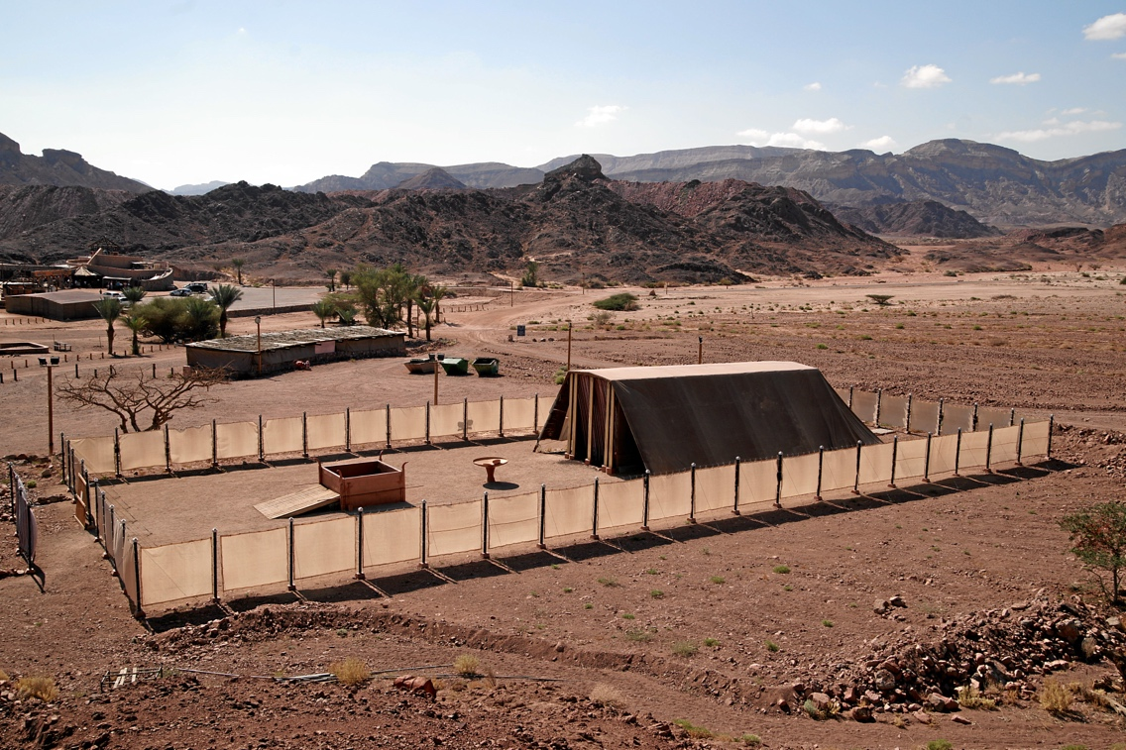
Day 13 – Thursday 7 December
We cross over the border to Jordan today to spend the day and night on Mars – that is, in the Wadi Rum – including a Lawrence of Arabia-style camel ride and “glamping” in a Bedouin tent!
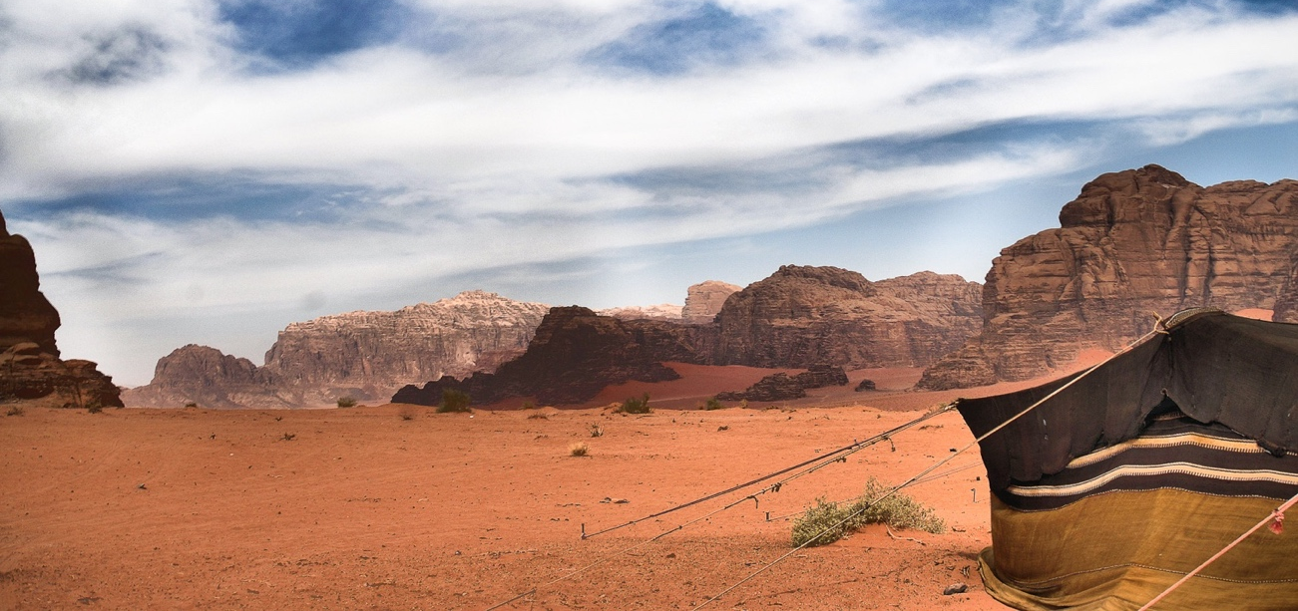

Day 14 – Friday 8 December
Will you choose wisely? We’ll spend the day exploring Petra, one of the Wonders of the World, a stunning city carved out of the red rock faces. Then we drive to Feinan to spend the night in an ecolodge on the edge of the Wadi Dana.

Day 15 – Saturday 9 December
On our last day, we embark on a long drive to Amman, stopping at Madaba to see the famous Madaba Map, a Byzantine mosaic that is also the oldest surviving original map of the Holy Land. Finally, we look over the Jordan Valley back towards the Promised Land, just as Moses did, though he never had the opportunity to cross over himself. A fitting end to our adventure together!
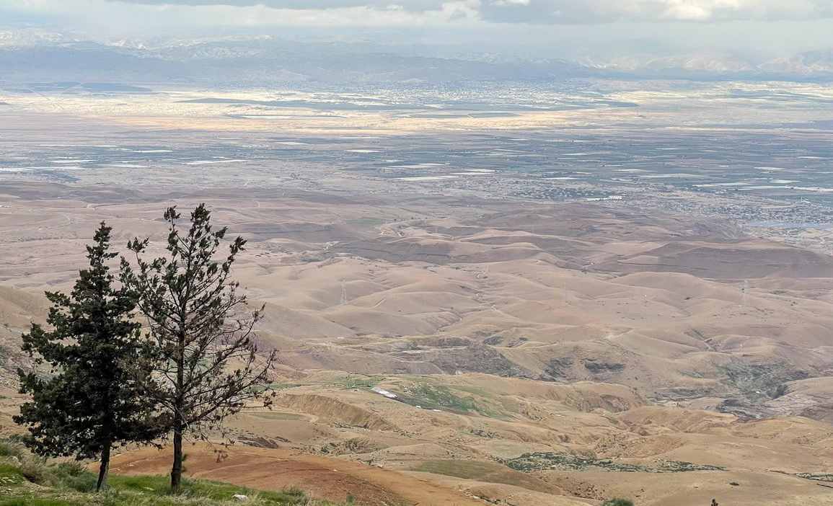

Day 16 – Sunday 10 December
Overflowing with memories and souvenirs, it’s time to head back to Australia!

Price
- Diploma $9,490 (FH $4,710 and Student contribution $4,780)
- Bachelor $10,120 (FEE-Help $5,340 and Student contribution $4,780)
- Masters $10,790 (FEE-Help $6,010 and Student contribution $4,780)
- Diploma International $9,700
- Bachelor International $10,350
- Masters International $11,000
- Audit $8,700
- Alumni/Student partners $8,600
- Staff %/Staff partners $8,200

Single room supplement: $1450

Hotels (standard rooms)
City | Dates | 3-4-star hotels or similar
Galilee | 25-29 Nov. 2023 | Nof Ginosar / Ein Gev / Ma’agan or similar
Jerusalem | 29 Nov. – 4 Dec. 2023 | Sephardic House or similar
Arad | 4-6 Dec. 2023 | Inbar Arad or similar
Eilat | 6-7 Dec. 2023 | Nova / Leonardo Royal resort / Leonardo Privilege or similar
Wadi Rum Regular tent | 7-8 Dec. 2023 | Sun City camp / Oasis camp / Mazayan Luxury camp / Sultana camp / Yasmina camp / Hasan Zawayden camp or similar
Petra | 8-9 Dec. 2023 | Petra Moon / P Quattro / Panorama / Canyon hotel or similar
Amman | 9-10 Dec. 2023 | Geneva hotel / Gerasa / Monarch hotel or similar

Inclusions: Exclusions:
The attached itinerary includes the following:  - Meet and assist upon arrival and departure.  - Transfer from Amman a/p to Sheik Hussein border  - Transfer from Sheik Hussein border to the Galilee  - Passport, border crossing from Jordan to Israel (Jordan departure tax / $15 USD) per person. Subject to change  - Passport, border crossing from Israel to Jordan (109 shekels Israel departure tax / approx. $30 USD). Subject to change  - First visa fee USD 57 per person. Subject to change. Second visa is free of charge.  - Departure transfer from Amman to Queen Alia a/p  - 12 full days Modern A/C motor coach transportation in Jordan and Israel  - 3 days English speaking guide in Jordan touring  - 9 days English speaking guide in Israel touring  - 15 over-nights in twin share accommodation in  3-4-stars hotels as mention above or similar  - Meals – Breakfast and Dinner daily at hotels  - 1 fish lunch in Galilee / 1 Nazareth Village lunch /  1 Ramon lunch / 1 Wadi Rum lunch  - Entrance fees for the above mentioned sites except Feyman visit  - 2 hours tour in Wadi Rum by open Bedouin trucks  - 1 hour camel ride in Wadi Rum  - Headset in Jordan and Israel  - Pilgrims gift packs | The above mentioned does not include:  - Tips for guides and drivers and porters (US$159)  - Any extra meals or beverages or hotel extras  - Personal expenses  - Travel insurance  - Donkeys or Horse ride in Jordan  - Club cars ride in Petra  - Sheik Hussein shuttle bus  - Headsets lost $100 per set.  - Any item not mentioned in the inclusions  - TBC: Interstate flights to depart from Sydney (further information to be sent out shortly)

